**Introduction**

This document explains briefly how to create an interface through Ethernet.

**Resources**

PC running Windows 7 with the following software:

• Kinetis Design Studio (KDS) v2.0.0

• MQX for KSDK v1.1.0

Hardware:

• FRDM-K64F

1. **Implementation**

#### By now a ‘*New MQX RTOS for KSDK Project Wizard’* does not exists. For this Lab use **‘MQX for KSDK Lab 4 - Base Project’**.

#### **Note:** If you want to know how to create a base project using RTCS see the **‘Appendix’** in this document.

#### Copy all the files from **‘MQX RTOS for KSDK TCP Server’** folder to the ´**Sources´** folder in your project; after copying the files, **'Sources'** folder should look like this:

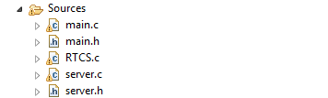

#### Build your application, go to **menu Project > Build Project.** Alternately click the hammer button.

#### Debug your application, go to **Debug Configurations**.

#### 

#### Double click on GDB Segger J-Link Debugging.

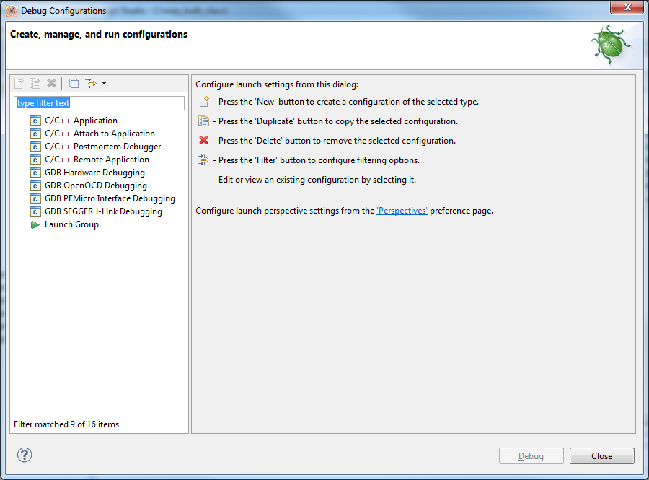

#### Click on **Debug**.

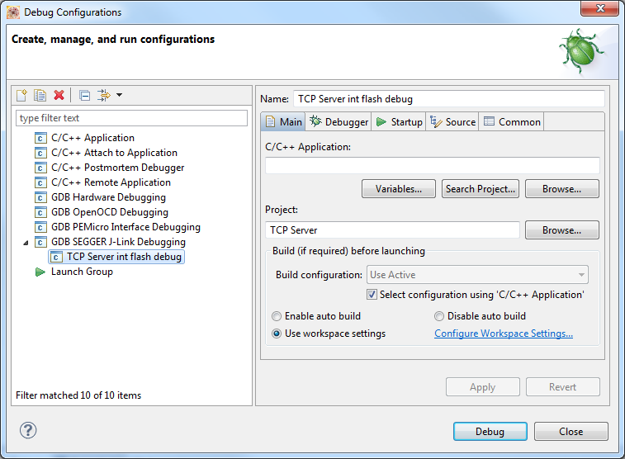

#### Open a terminal, select the appropriate port and baud rate.

#### 

#### Click **Resume**. Alternately press F8.

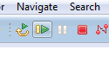

#### After running your project and configuring the terminal, you should see the following message on the terminal (Without the Ethernet cable connected).

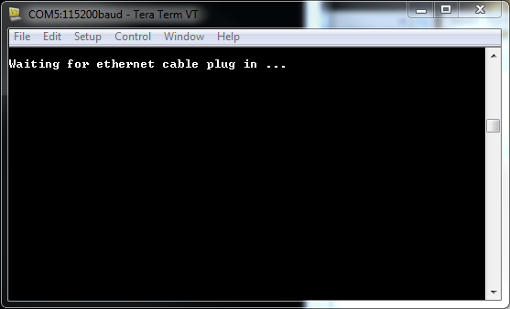

### How does it work?

#### Open **´main.c´** of your project, as you can see, we have the Main task and the Server task. The Main task is set up as "Auto Start" this means that when we run the project, this task is automatically started.

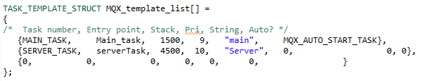

#### This task initializes the RTCS and all the networking settings. If the input parameter is 0 an static IP is assigned to the Kinetis device and if 1 assigns a dynamic IP using DHCP. Then it creates a "Server" task which is not executed until "Main Task" finishes as Client task has a lower priority.

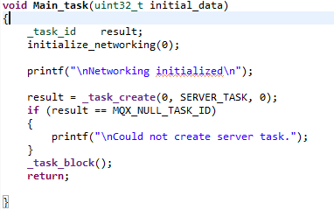

#### The second task is “serverTask”, it is located in **´Server.c´** of your project. These lines set the socket type and the connection port.

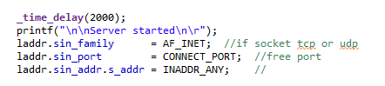

#### The socket is created and checks if there was an error.

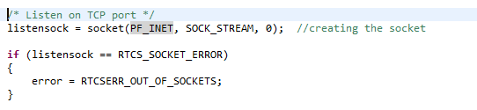

#### Bind socket to IP address and wait for the connection to be accepted. If there was an error, the connection ends.

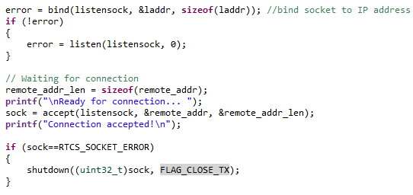

#### In this section the server receives the message from the client and responds with "Hello" and the function "InitializeIO()" initializes a led.

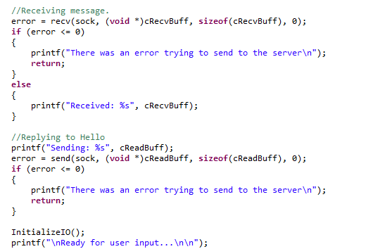

#### The socket is created and checks if there was an error. Once everything was configured, the program enters an infinite loop, and has 2 options:

* If you receive "T" it prints "LED was toggled" and toggles the LED 1.
* If you receive "G" it prints "Shutting down connection" and ends connection.

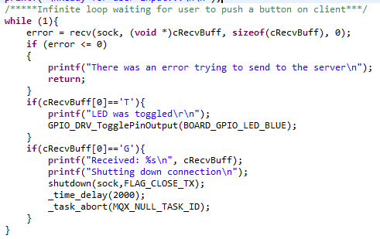

1. **Appendix**To create a new project you will have to copy/paste the httpsrv_frdmk64f located in

***C:\Freescale\KSDK_1.1.0\tcpip\rtcs\examples\httpsrv***

into your workspace and rename it. When you copy/paste a project into your workspace, your sources folder is linked to the original one, so if you change anything on your new project it will be changed in the original one too. To avoid this problem you will have to erase the sources folder of your new project and create a new one with the same name (this one will not be linked to the previous project).

* 1. If your workspace is not the same that the hello_frdmk64f project you will have to modify the paths of the project. To do this you will have to go to **Project->Properties->C/C++ Build ->Settings**
  2. You will have to change the every single path of the program, to do this you will have to look for the right path the program is referring. For example, in the

**Cross ARM GNU Assembler -> Includes** the first path will be **${ProjDirPath}/../../../../../../config/mcu/mk64f120m**

You will have to look into the installation folder **(C:\Freescale\KSDK_1.1.0)** the last directories of this path. In this case you will find it at

**C:\Freescale\KSDK_1.1.0\rtos\mqx\config\mcu\mk64f120m**.

* 1. Once you get the correct path you will have to click the add option.

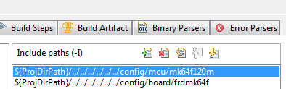

* 1. This window will appear, here you will have to add the correct path and substitute the **C:\Freescale\KSDK_1.1.0** with **${KSDK_PATH}** and then click ok.(Note: is important to have defined KSDK_PATH as an environment variable)

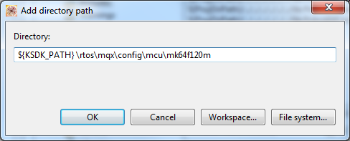

* 1. Once you have added this new path you can erase the other one. You will have to repeat this steps in the next folders.

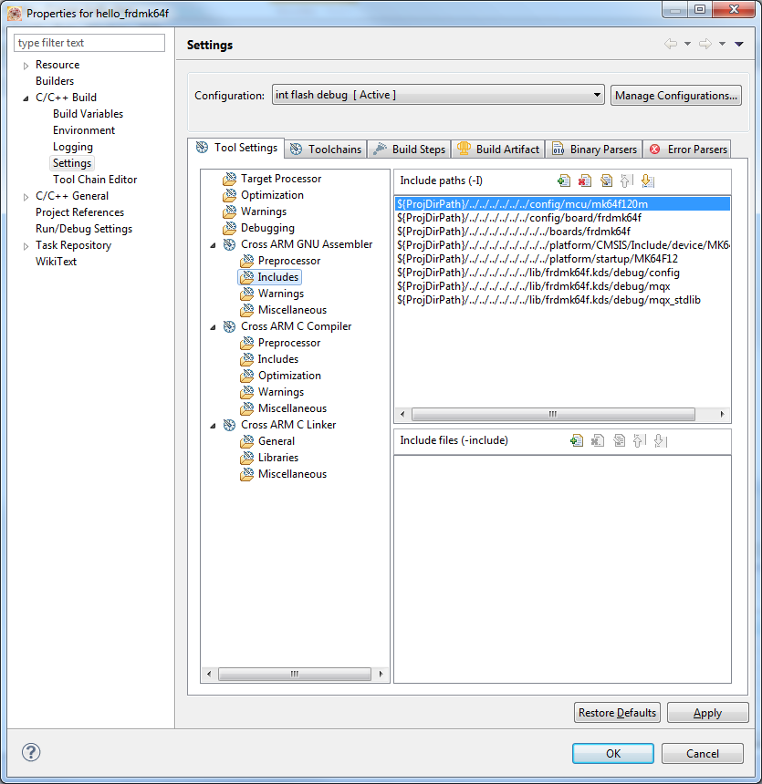

* 1. Your new paths will have to see as follows.

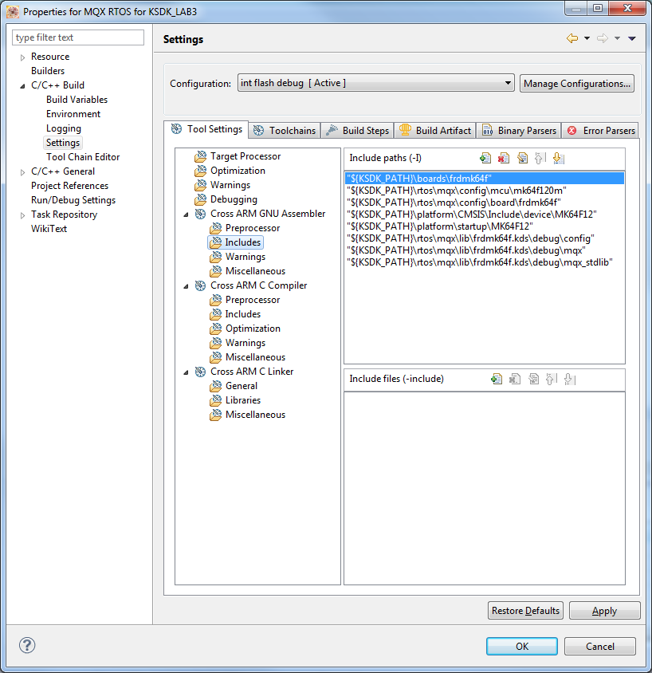

* 1. Once you change every single path you will be able to compile and debug your new project.
  2. Is suggested erase your actual source folder and create a new one with the same name. If you don’t do this your source folder will be linked to the original one and all your modifications will be made in that folder too.

All this process is necessary because the MQX RTOS for KDS wizard is still in development.